Project Design Phase-II

Data Flow Diagram & User Stories

|  |  |
| --- | --- |
| Date | 16/06/25 |
| Team ID | LTVIP2025TMID52137 |
| Project Name | Visualizing housing market trends: an analysis of sale  prices and features |
| Maximum Marks | 4 Marks |

**Data Flow Diagrams:**

A Data Flow Diagram (DFD) is a traditional visual representation of the information flows within a system. A neat and clear DFD can depict the right amount of the system requirement graphically. It shows how data enters and leaves the system, what changes the information, and where data is stored.

1. **Data collected** from POSOCO in CSV format.
2. **Cleaned and transformed**, with calculated fields like Year and Lockdown.
3. **Visualizations built** in Tableau using multiple worksheets.
4. **Users review** the dashboard and may request changes.
5. **Final version archived** after approval.

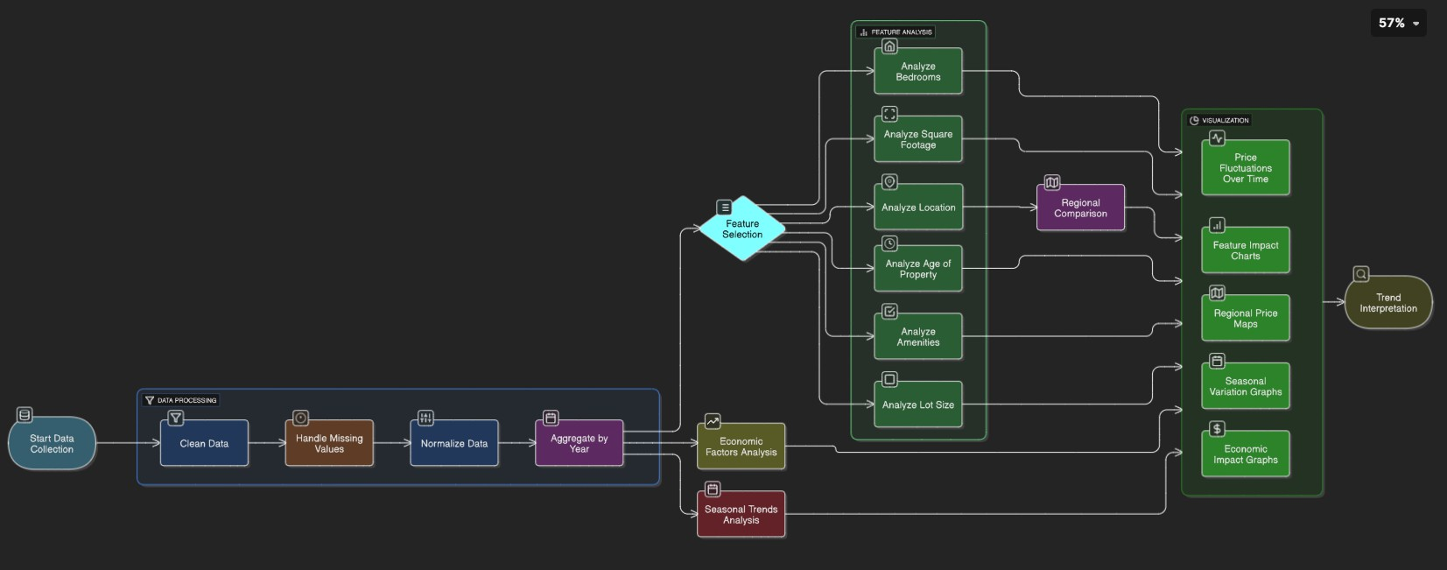

**User Stories**

|  |  |  |  |  |  |
| --- | --- | --- | --- | --- | --- |
| User Type | Functional Requirement (Epic) | User Story Number | User Story / Task | Acceptance Criteria | Priority & Release |
| Analyst / Policymaker | View Electricity Trends | USN-1 | As a user, I want to view electricity usage trends by region and year so I can identify peak periods. | I can filter and view charts for specific regions and years. | High / Sprint-1 |
| Analyst | Compare States | USN-2 | As a user, I want to compare the top and bottom electricity- consuming states. | I can view bar charts with top N and bottom N states. | Medium / Sprint-1 |
| Policy Maker | Forecast Planning | USN-3 | As a user, I want to analyze seasonal variations in usage to help plan future supply. | I can view monthly and quarterly consumption trends. | High / Sprint-2 |
| Energy Consultant | View Impact of Lockdown | USN-4 | As a user, I want to compare electricity usage before and after lockdown. | A before-after lockdown chart is available for selection. | High / Sprint-2 |
| Developer | Connect Data | USN-5 | As a user, I want the dashboard to be connected to a live  database. | Data refreshes automatically from MySQL to Tableau. | Medium / Sprint-2 |
| Developer | Export Insights | USN-6 | As a user, I want to export dashboard views for use in presentations. | I can download dashboards as image or PDF formats. | Low / Sprint-3 |